# Library Management system

Mini-Project-1B report submitted in partial fulfilment of the requirements of the degree of

### Information Technology

by

**Reenav Hemaria PID No. EU1194028 (Roll no. 7) Shubham Kerkar PID No. EU1194042 (Roll no. 12) Siddhesh Chavan PID No. EU1194007 (Roll no. 1) Aishwarya Ingale PID No. EU1194033 (Roll No. 8)**

Under the guidance of

**Ms. Shraddha S. More Assistant Professor**



### Department of Information Technology

**St. John College of Engineering and Management, Palghar**

### University of Mumbai

(A.Y. 2020-2021)

**CERTIFICATE**

This is to certify that the Mini Project-1B entitled **“Library Management system”** is a bonafide work of “**Reenav Hemaria PID No. EU1194028 (Roll no. 7), Shubham Kerkar PID No. EU1194042 (Roll no. 12), Siddhesh Chavan PIDNo.EU1194007 (Roll no. 1)** and **“Aishwarya Ingale PID No. EU1194033 (Roll No. 8)** submitted to University of Mumbai in partial fulfilment of the requirement for the award of the degree of **“Bachelor of Engineering”** in **“Information Technology”**.

**Ms. Shraddha S. More**

Guide

**Mrs. Anita Chaudhari Dr. G.V. Mulgund**

Head of Department Principal

# Mini-Project-1B Report Approval

This mini-project synopsis entitled **“Library Management system”** by ***Reenav, Shubham, Siddhesh*** and ***Aishwarya*** is approved for the degree of **Bachelor of Engineering** in **Information Technology.**

**Examiners:**

1. (Internal Examiner Name & Sign)

2. (External Examiner name & Sign)

Date: 24/05/2021 Place: Palghar

3

# Declaration

We declare that this written submission represents our ideas in our own words and where others’ ideas or words have been included, we have adequately cited and referenced the original sources. We also declare that we have adhered to all principles of academic honesty and integrity and have not misrepresented or fabricated or falsified any idea/data/fact/source in our submission. We understand that any violation of the above will be cause for disciplinary action by the Institute and can also evoke penal action from the sources which have thus not been properly cited or from whom proper permission has not been taken when needed.

Reenav Hemaria (EU1194028)

Shubham Kerkar (EU1194042)

Siddhesh Chavan (EU1194007)

Aishwarya Ingale (EU1194033)

Date: 24/05/2021

## Abstract

* The Library Management System is an application for assisting a librarian in managing a book library in a university.
* The system [would provide basic set of features to add/update members, add/update books, and manage check in specifications for the systems based on the client’s statement of need.
* Library management system is a typical management Information system (MIS), its Development include the establishment and maintenance of back-end database and front-end application development aspects.
* For the former require the establishment of data consistency and integrity of the strong data security and good libraries.

## Table of Contents

|  |  |  |
| --- | --- | --- |
|  | **Abstract** | **5** |
|  | **List of Figures** | **7** |
|  | **List of Abbreviations** | **8** |
| **Chapter 1** | **Introduction** | **9** |
|  | 1.1 Motivation | 9 |
|  | 1.2 Problem Statement | 10 |
|  | 1.3 Scope | 10 |
| **Chapter 2** | **Review of Literature** | **11** |
| **Chapter 3** | **Requirement Analysis** | **13** |
|  | 3.1 Hardware and Software Requirements | 13 |
| **Chapter 4** | **Report on Present Investigation** | **14** |
|  | 4.1 Proposed System | 14 |
|  | 4.1.1 Block diagram of Proposed System | 14 |
|  | 4.2 Implementation | 15 |
|  | 4.2.1 Algorithm/Flowchart | 15 |
|  | 4.2.2 Database | 16 |
|  | 4.2.3 Code | 17 |
|  | 4.2.4 Screenshots of the output with description | 49 |
| **Chapter 5** | **Results and Discussion** | **54** |
| **Chapter 6** | **Conclusion** | **55** |
|  | 6.1 Conclusion | 55 |
|  | **References** | **55** |
|  | **Acknowledgement** | **56** |

**List of Figures**

|  |  |  |
| --- | --- | --- |
| **Figure No.** | **Figure Name** | **Page No.** |
| 4.1.1 | Block diagram of Proposed System | **14** |
| 4.2.1 | Algorithm/Flowchart | **15** |
| 4.2.2 | Database | **16** |
| 4.2.3 | Code | **17** |
| 4.2.4 | Screenshot of the output with description | **49** |

## List of Abbreviations

|  |  |
| --- | --- |
| **SJCEM** | St. John College of Engineering and Management |
| **LMS** | Library Management System |

**Chapter 1: Introduction**

Library management system was the typical application of information management system. Its development mainly included the establishment and maintenance of database and head application development.

For the former requirement to establish data consistency and integrity. The integrity required the application function, easy to operate.

Based on the above consideration, this system mainly adopt VB6.0 as the front-end application development tools. SQL Server was applied to back-end database. Windows was the system platform development books management system management system.

Overall listing the structured method for system analysis and design of life, while the prototype system between step and the method of facing object.

### Motivation

Libraries are essential in a process of giving

citizens access to knowledge. In digital times they are needed more

than ever before. In our country, library systems are written that’s why

we make a great use of paper. By making paper we cut trees. It is very

harmful for our environment. For our environment, we take this step to

reduce this.

### Problem Statement

* Libraries are used to store books, but require a system to navigate to a specific book or specific content within a book.
* A library database system is an infrastructure that allows users to search books and book content, add/remove, and download selected books.
* The problem faced is that library users require an efficient method to find a specific book or keyword(s) within a book given a continuously expanding library.
* Efficiency requires that the processing time should stay relatively the same even as the library contents increases.

### Objectives

The objectives are as follows:

a) To build a system that can receive input and generate automatically output in easy way and short time.

b) To build a monitoring system that is able to monitor and manage all library operations efficiently.

c) Give an opportunity to librarians to reduce mistakes that always happen during manual method.

d) To store properly the library items in order to maintain their security.

e) To enter and preserve details of the various issues and keep a track on their returns.

This system basically has four types of modules that handle daily activities for the library :

a) Manage Account module

b) Search Record Module

c) Book Borrowing System Module

d) Report Generator Module

## Chapter 2: Review of Literature

|  |  |  |  |  |
| --- | --- | --- | --- | --- |
| **Sr.**  **No.** | **Paper Title**  **[Ref.]** | **Author’s names** | **Conclusion** | **Research Gap** |
| **[1]** | Library management system | R. Earnshaw. | Reduced data redundancy | Hard and complex system. |
| **[2]** | Electronic Resources and libraries website | Jill emery  Graham stone | The sole purpose of this paper to bring pen and paper records into electronic means. | Hard and complex system. |

**Chapter 3: Requirement Analysis**

## 3.1 Details of Hardware & Software

### PC with i3 processor and 4 Gb Ram.

* **Visual Studio Code (IDE) For Writing Python Program.**

## Chapter 4: Report on Present Investigation

### Proposed System

* + 1. **Block diagram of Proposed System**

Main Frame

### Implementation

* + 1. **Algorithm and Process Design**

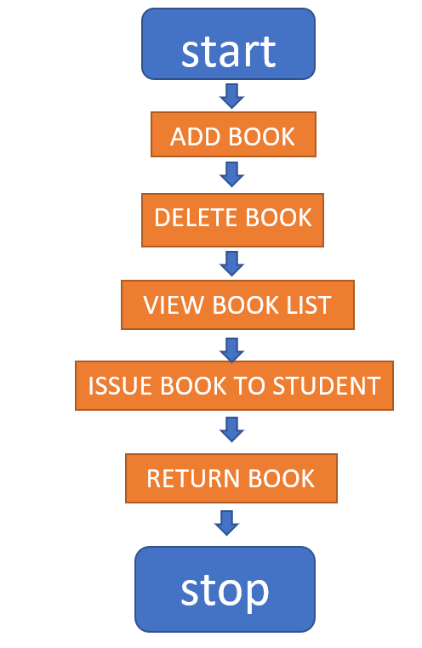

### Database

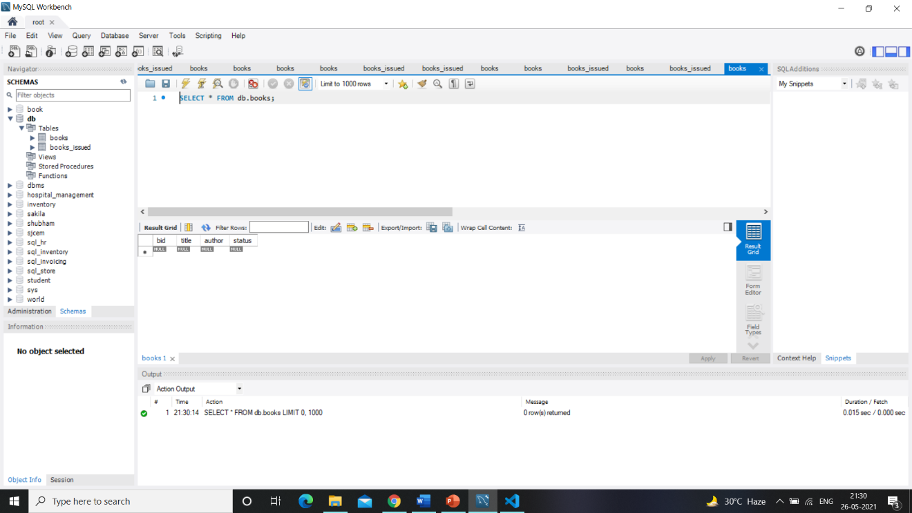

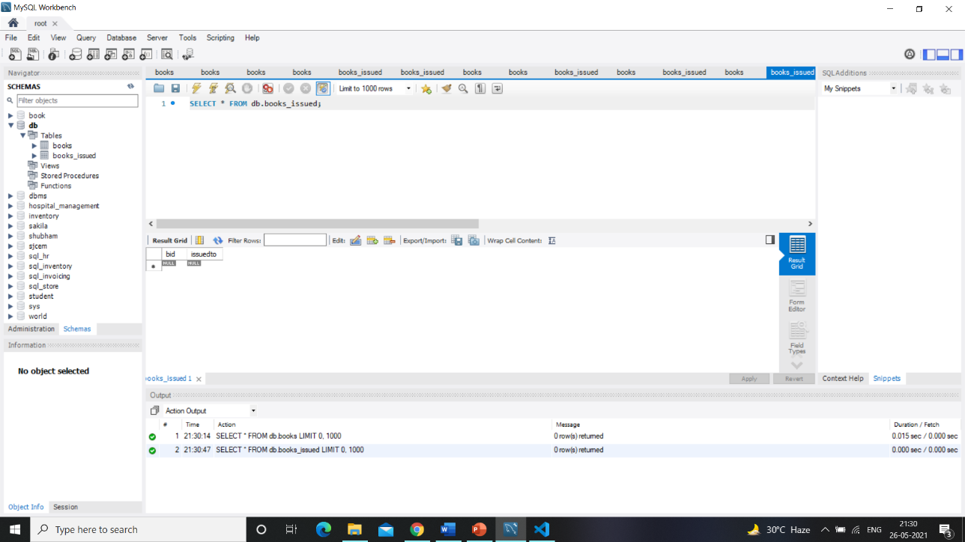

* + 1. **Code**

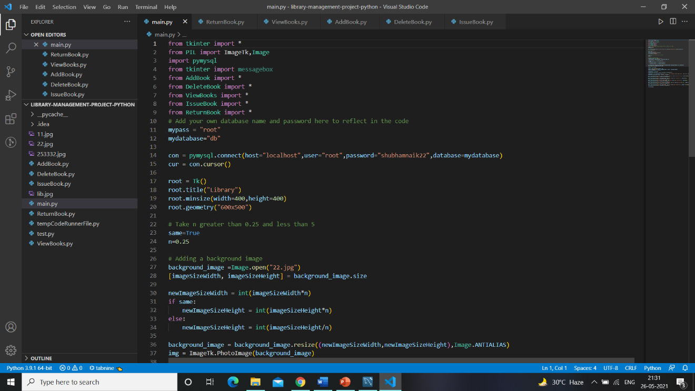

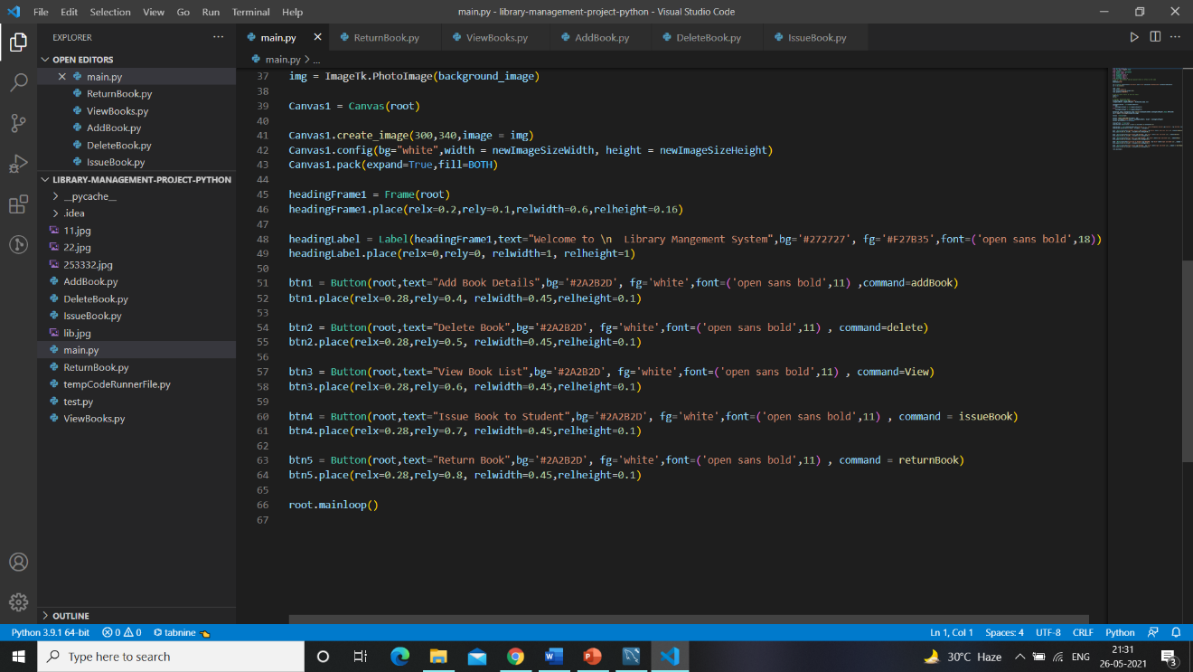

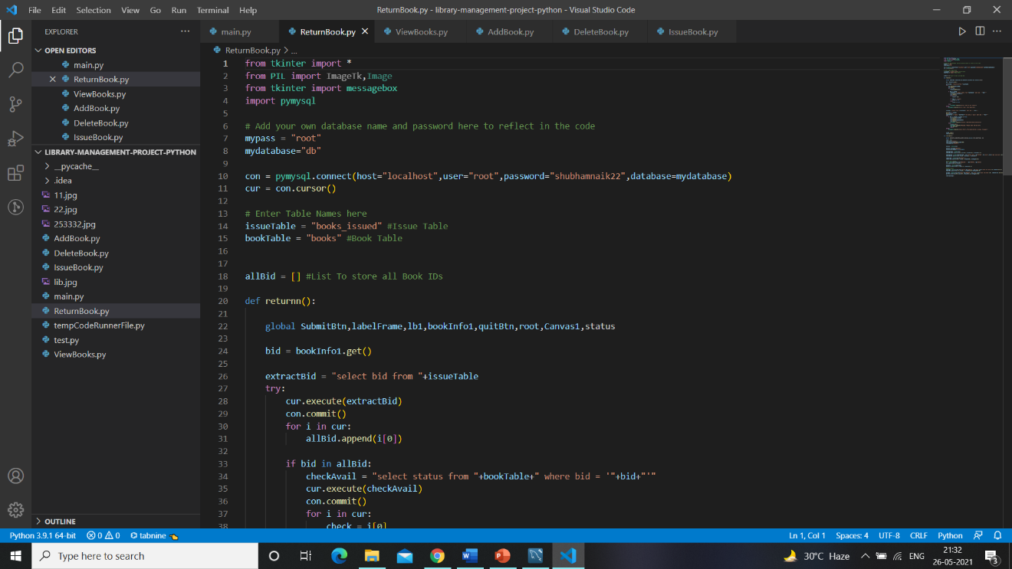

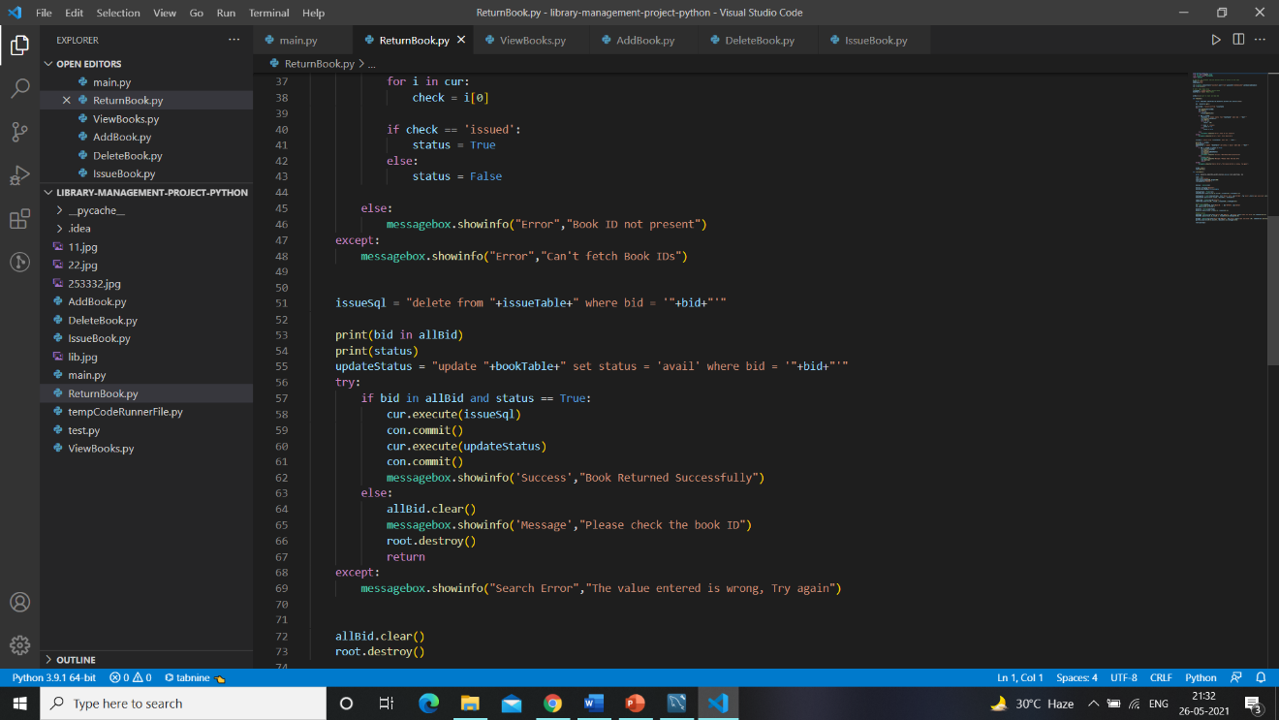

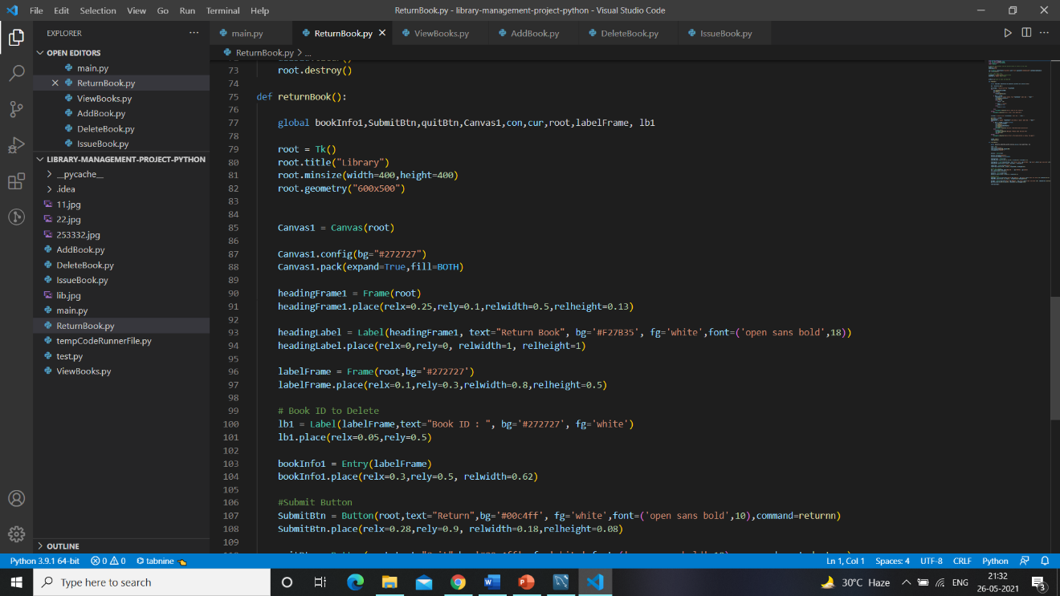

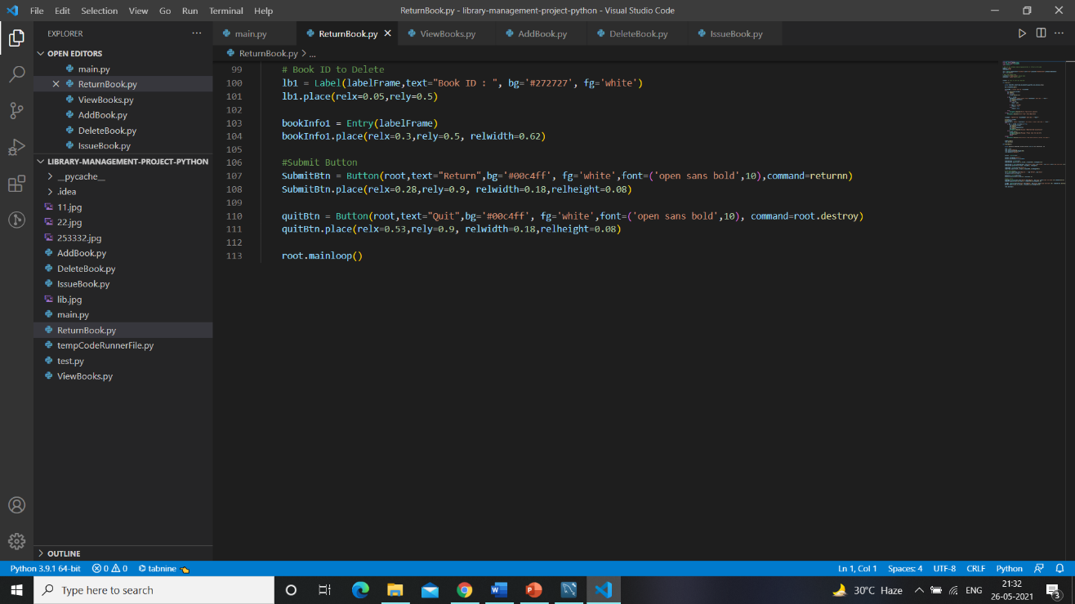

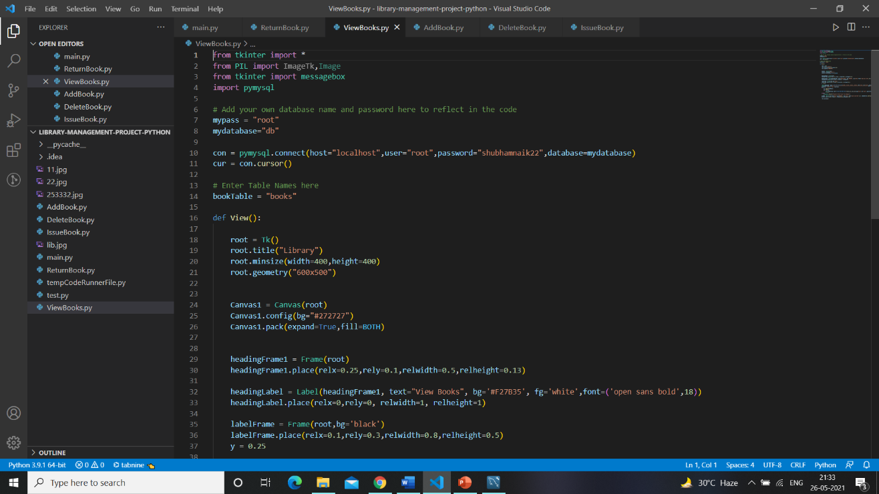

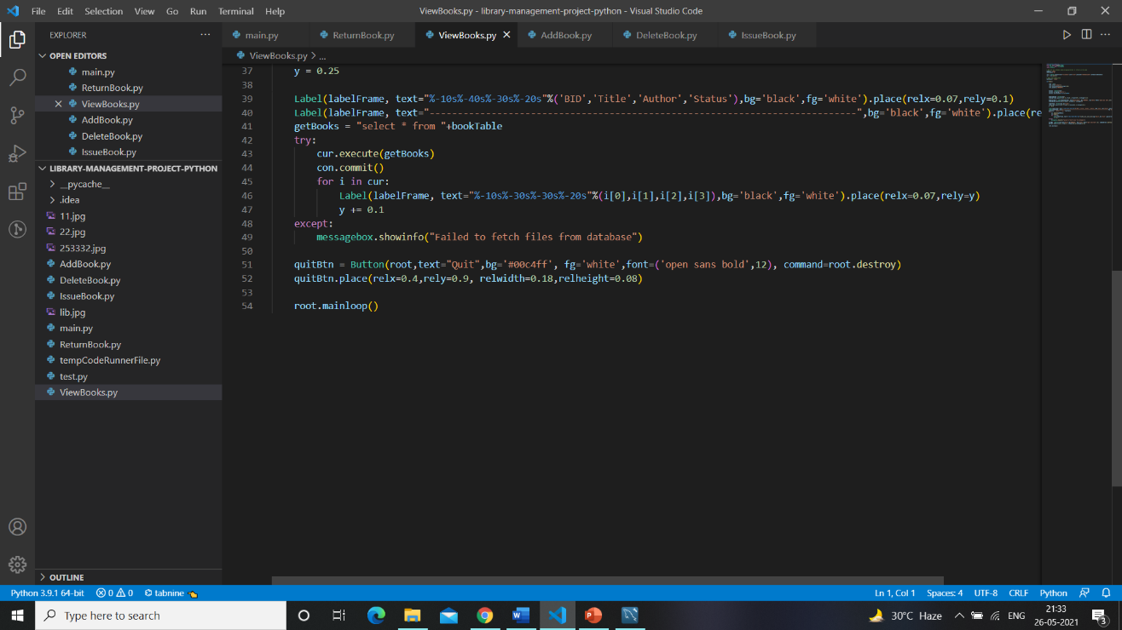

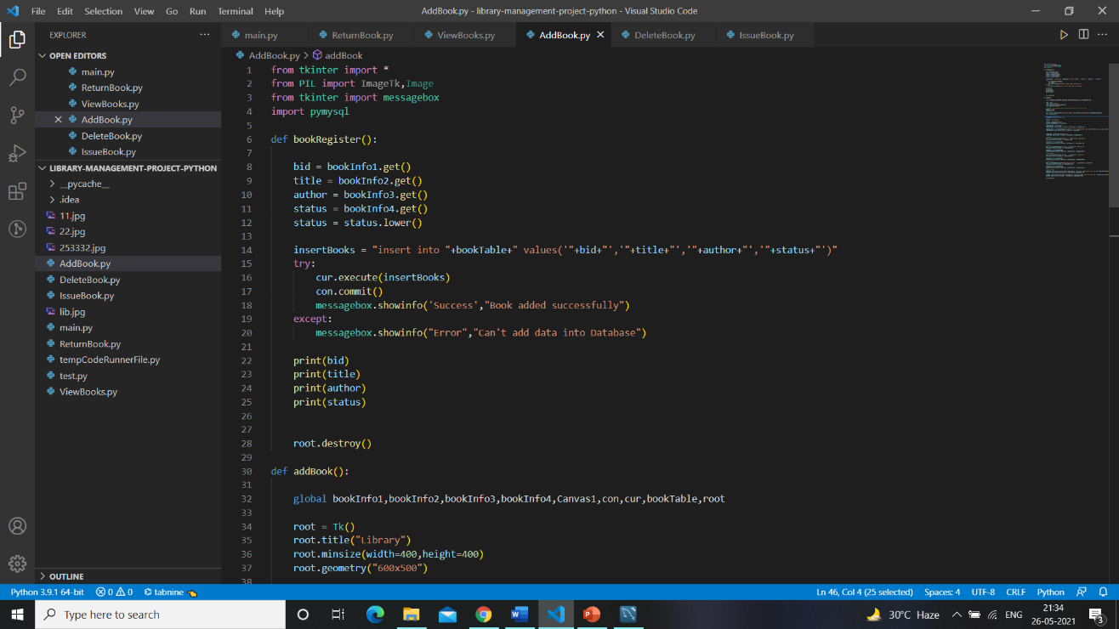

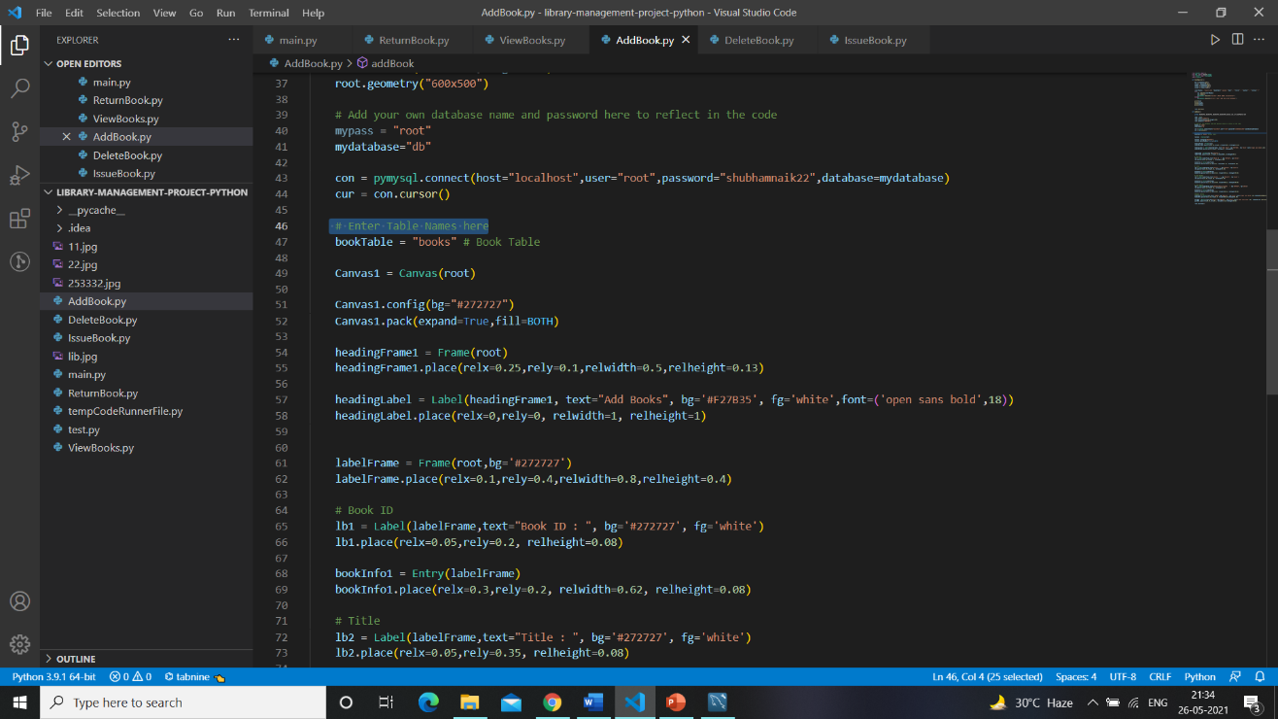

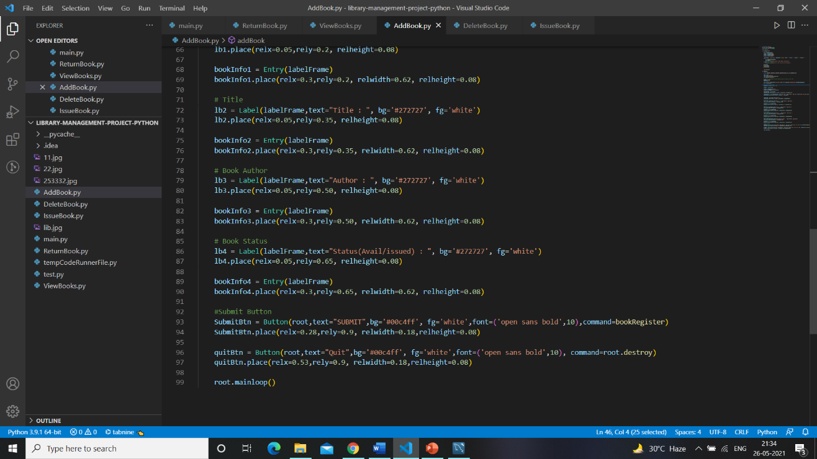

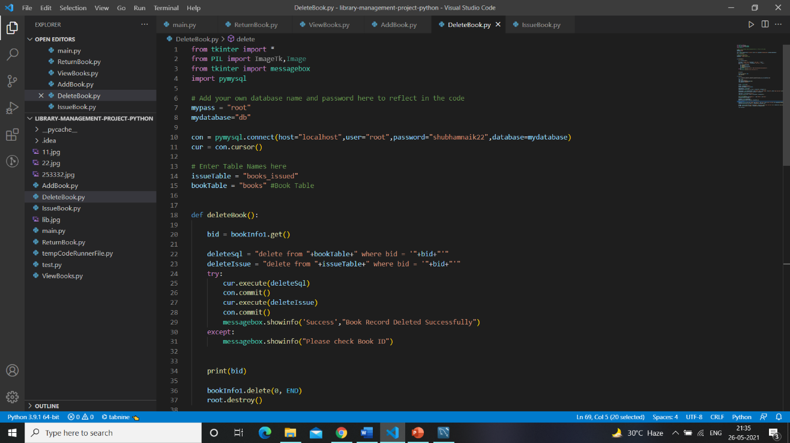

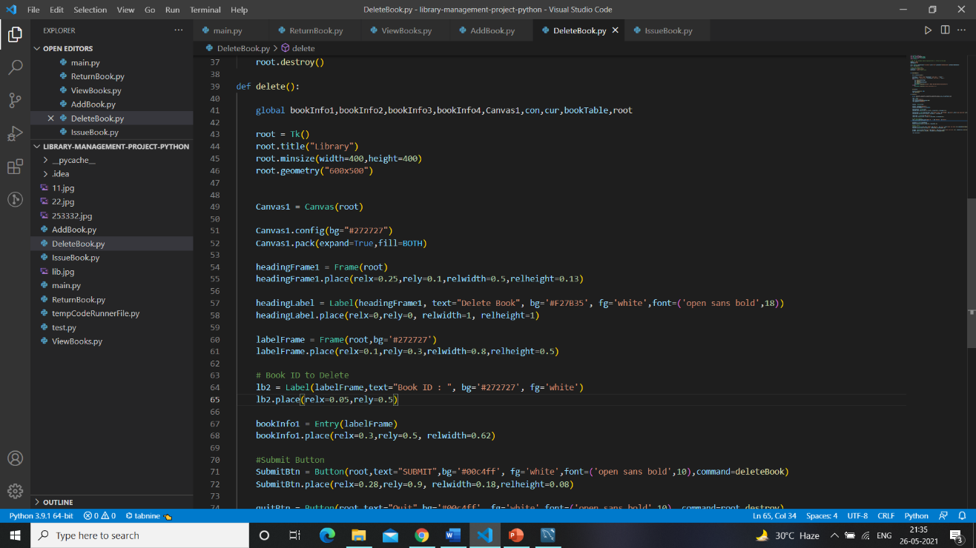

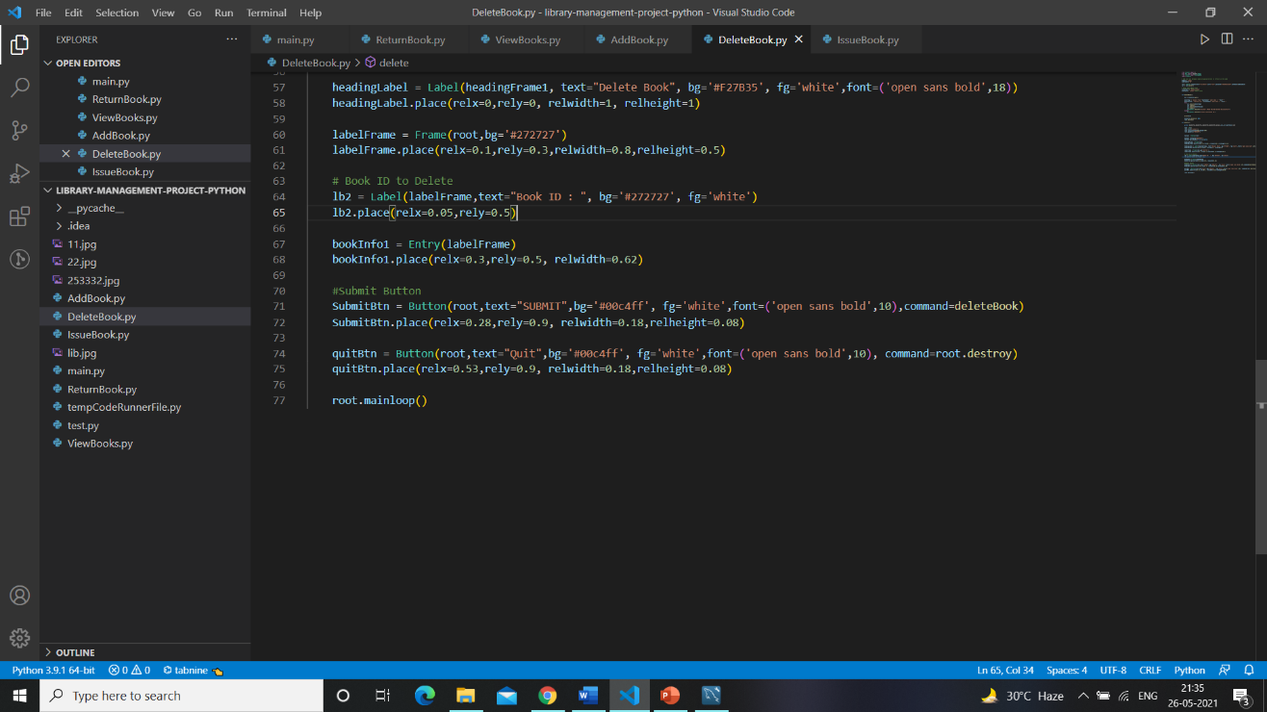

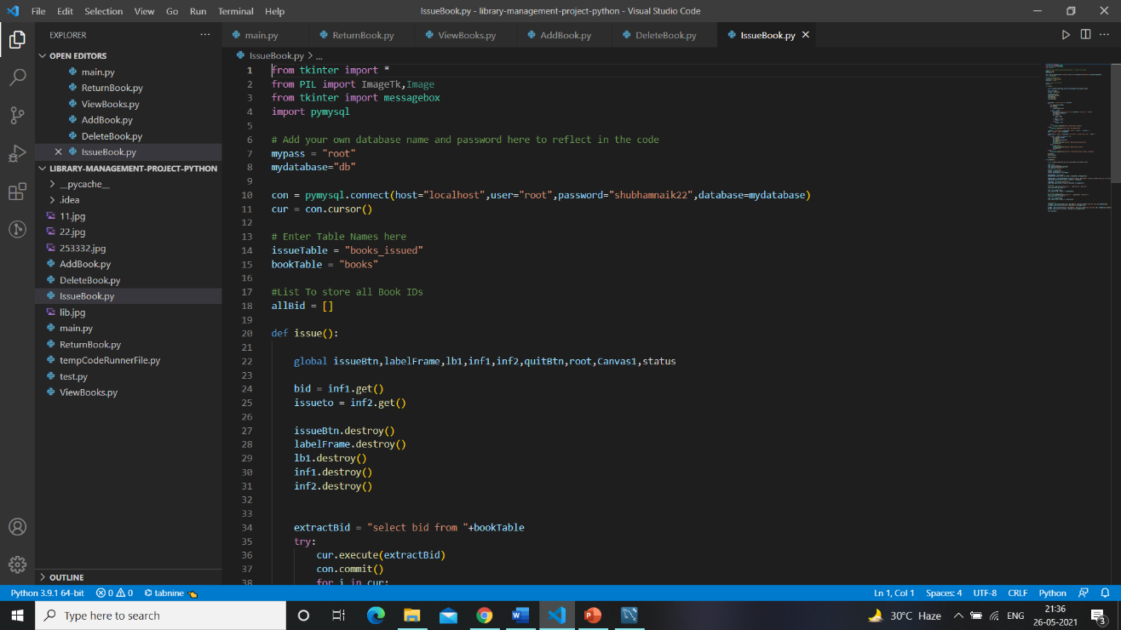

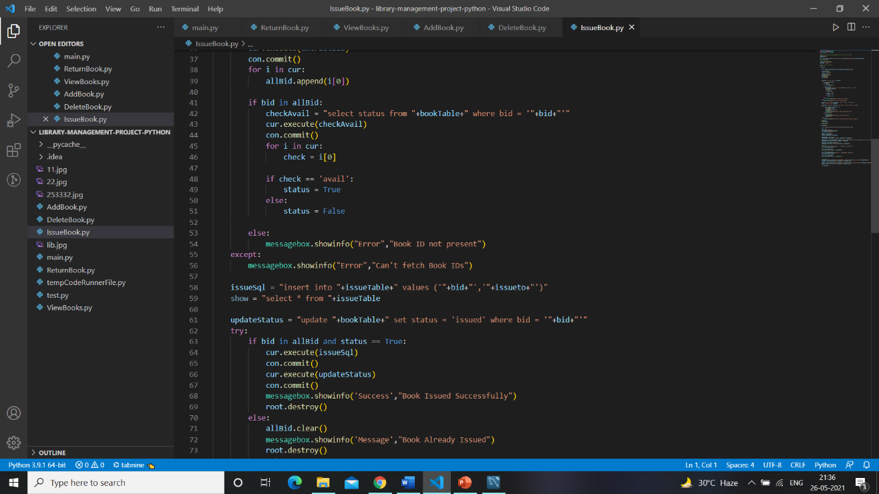

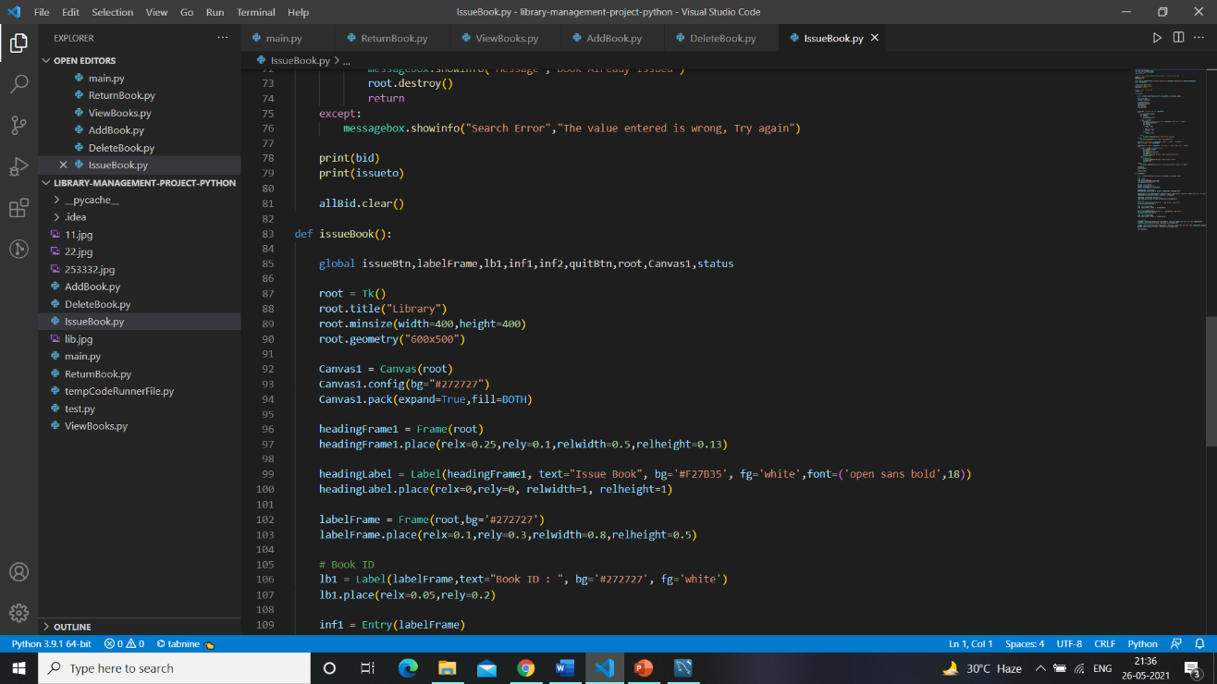

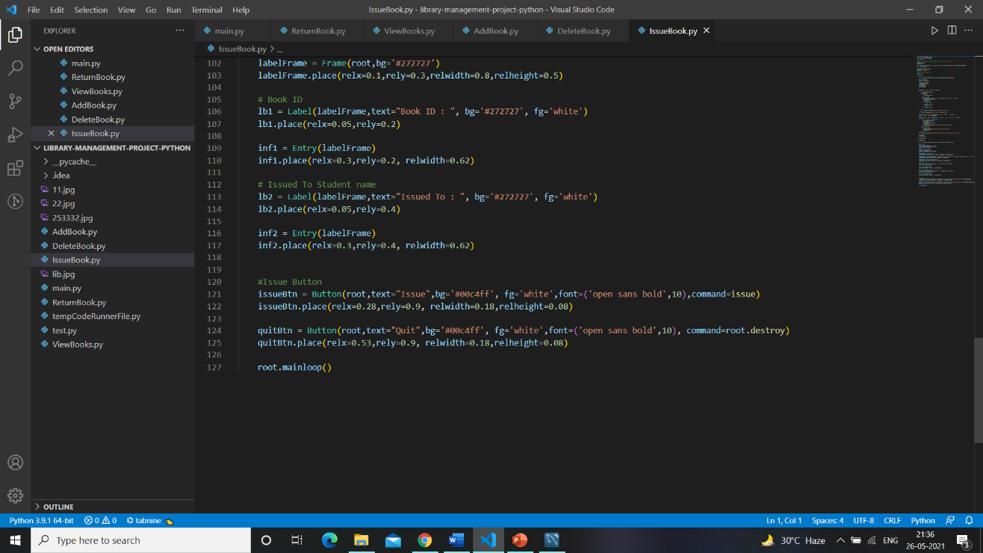

* + 1. **Screenshots of the Output with Description**

### When you run the code this page will show on screen.

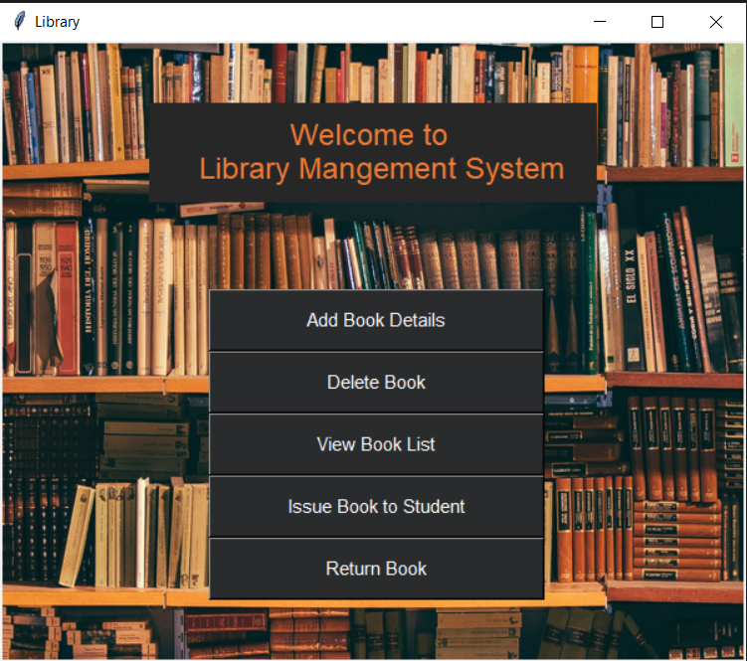

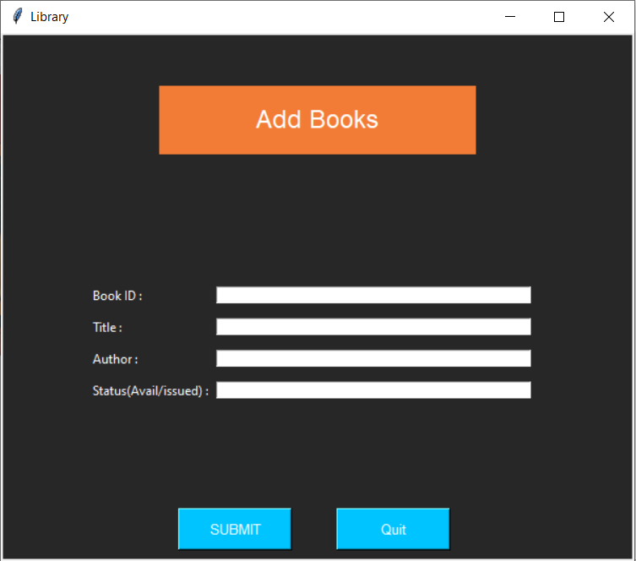

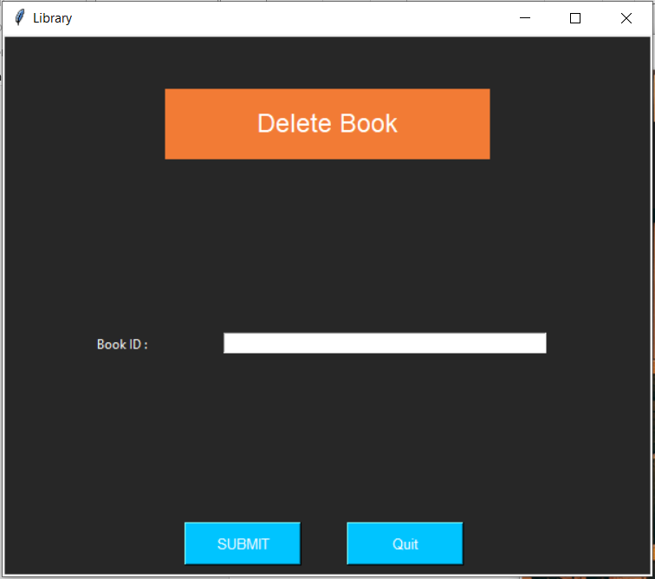

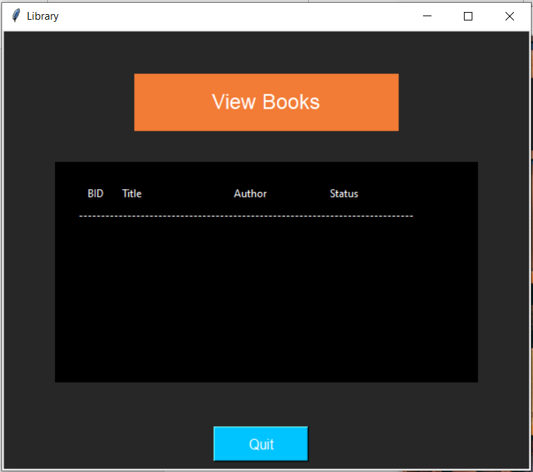

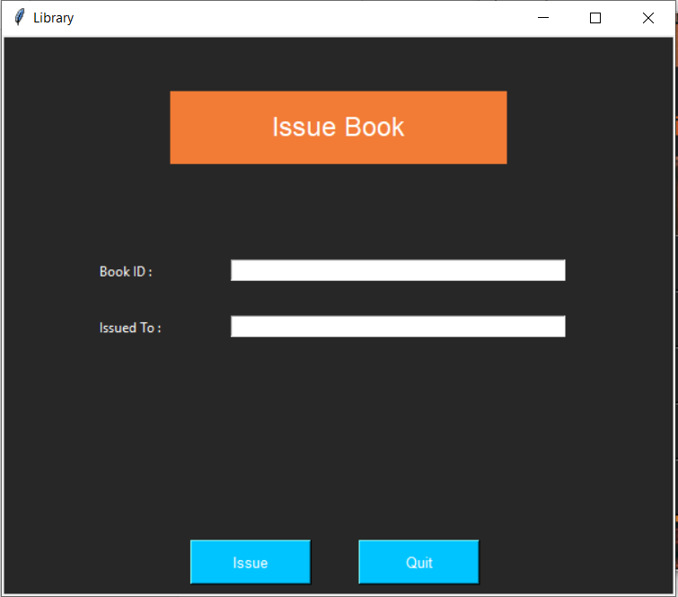

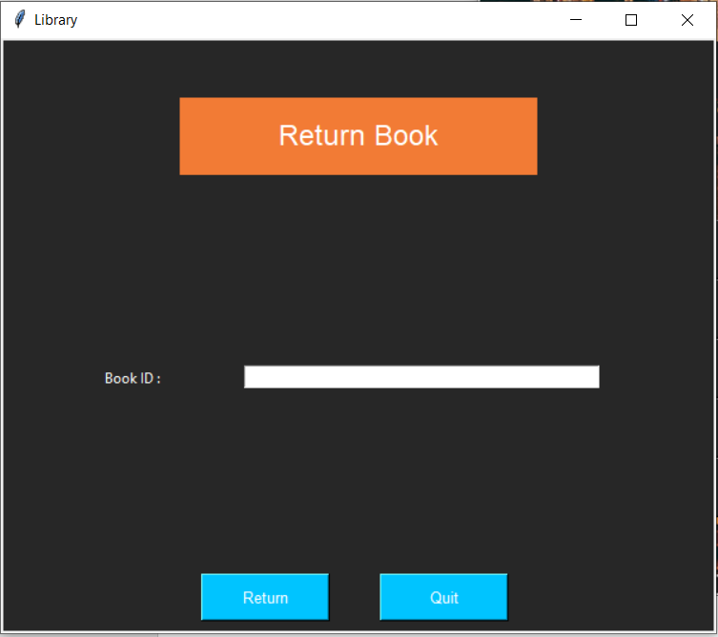

**Chapter 5: Results and Discussion**

After the system developed, process of system testing must be carry on in order to test if the system is free of bugs. If during the system testing, there are bugs or errors detected, the developer may need to correct and fix the bugs immediately.

Testing is conducted to assess the quality of a system hence can be said to be a validation and verification process. This ensures that system meets the technical requirements that guided its design and development, works as expected and can be implemented with the same characteristics.

There are few types of system testing that must be performed which include the unit testing, integration testing, system testing, and acceptance testing.

## Chapter 6: Conclusion & Future Work

**Conclusion:**

The Internet has become a major resource in modern life, thus library management system has gained significance not only from the management staff but also from the student’s point of view.

For the management, library system generates new books opportunities and for the student, it makes comparative selecting possible.

As per a survey, most students of online library system are impulsive and usually make a decision to stay on a site within the first few seconds.

Hence, the project has been designed to provide the user with easy navigation, retrieval of data and necessary feedback as much as possible.

**Future Work:**

we have many scope for developing our Application. We can make this application as Server based application. In our application we don’t have student’s interaction to this application. We can make this happen in future. We can make this application as an android application which is very helpful to the user and the library authority.

**References:**

* https://pdxscholar.library.pdx.edu/ulib_fac/301/

# ACKNOWLEDGEMENT

In performing our project, we had to take the help and guideline of some respected persons, who deserve our greatest gratitude. The completion of this project gives us much Pleasure. We would like to show our gratitude Mrs. Shraddha More for giving us a good guideline for project throughout numerous consultations. We would also like to expand our deepest gratitude to all those who have directly and indirectly guided us in writing this assignment.